

**KAUNAS, 2020**

**TESTING OF PAGE www.dekoria.lt**

**Final project**

**Jolita Budrikienė**

**Contents**

3. Introduction 3

4. Testing section 3

5. Check list 4

6. Detailed Test case 5

7. Founded issues 9

8. Improvement 12

9. Test Design Technics 13

10. Reflection 13

# **3. Introduction**

This document is SDA academy final project. Here I’m going to describe chosen internet page structure, mention testing areas. Testing subject - page: <https://www.dekoria.lt/>. Main goals- test chosen parts of page, present test scenarios and test cases, find and present bugs and suggest improvements to page.

# **4. Testing section**

Home page of <https://www.dekoria.lt/> consists of main sections: Header menu, Menu 1, Menu 2. Footer menu. Menu 2 and some parts of Footer menu/Įdomu have subsections inside. Testing sections are marked in navy ovals.



Please look into attached additional file “Page schema” for more detailed information.

# **5. Check list**



Please look into attached additional file “Checklist” for more detailed information.

# **6. Detailed Test case**

Detailed test cases are written for areas marked in testing section.







Please look into attached additional file “Detailed test cases” for more detailed information.

# **7. Found issues**

Found issues are registered in “Backlog”. Most of issues are UI bugs, as:

* Didn’t keep one style of titles per pages;
* Grammar, numbering and punctuation mistakes;
* Didn’t set correct lines alignment;
* Artworks in different sizes, not aligned;
* Artworks titles in different languages.

Validation bugs:

* Password validation isn’t set, system allows registering with only one symbol in password, validation message doesn’t come;
* System allows e-mail with .com.com.

Functionality bugs:

* Link to info@dekoria.lt from main page is not active.

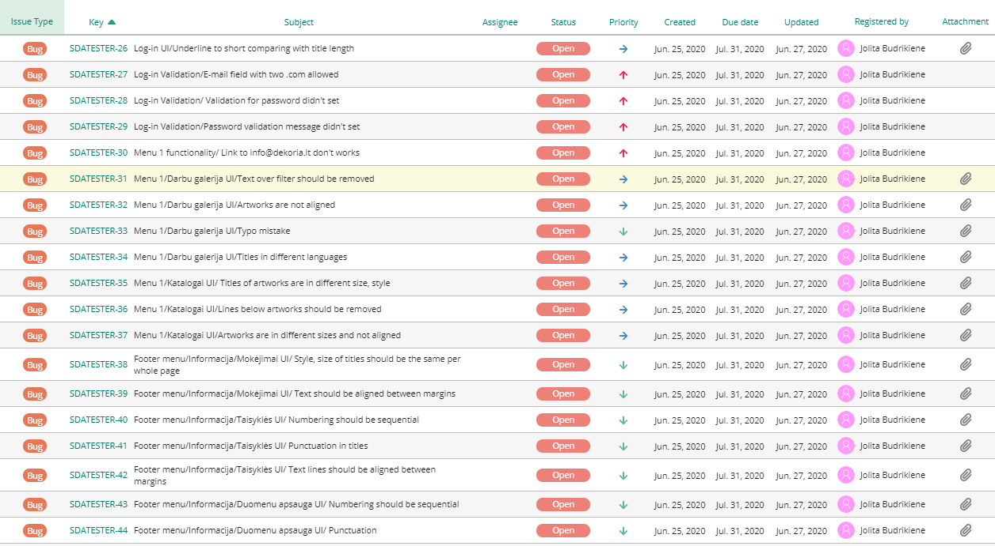



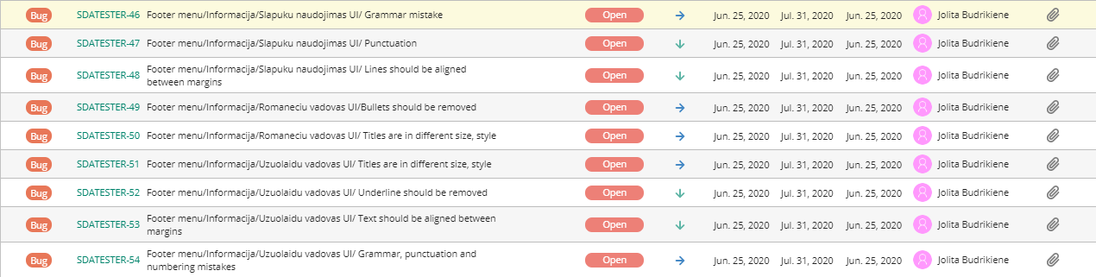

Examples of registered bugs:

Validation bug:

1. 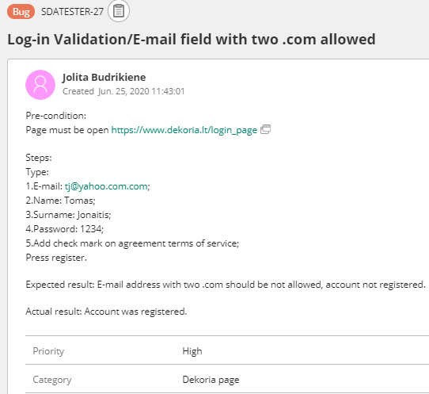

UI bugs:

1. 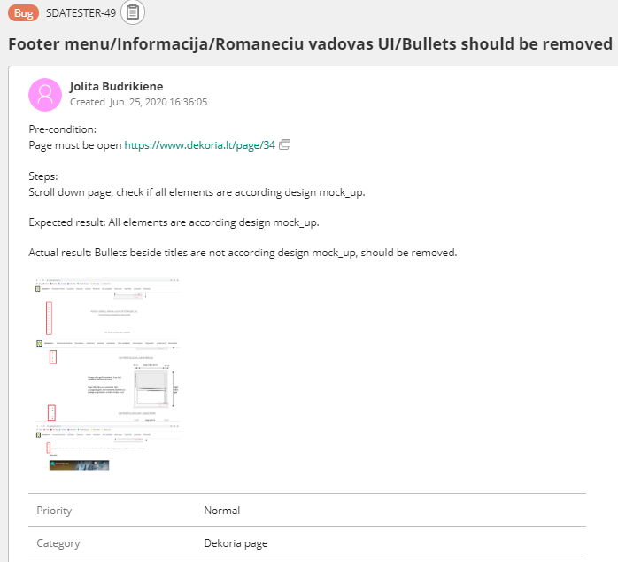
2. 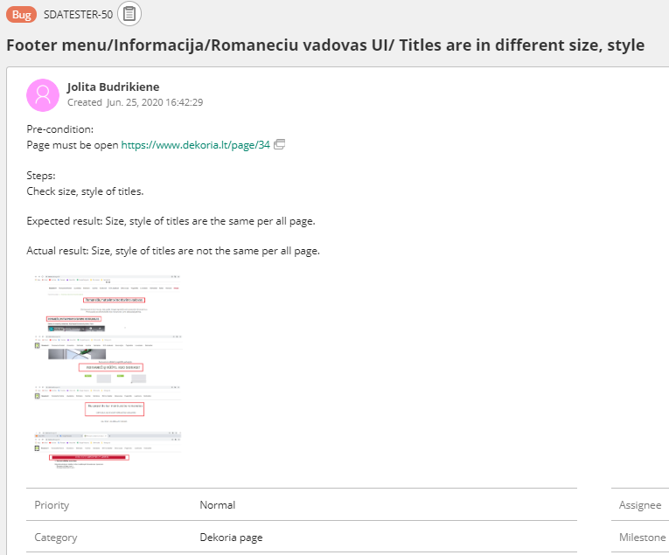
3. 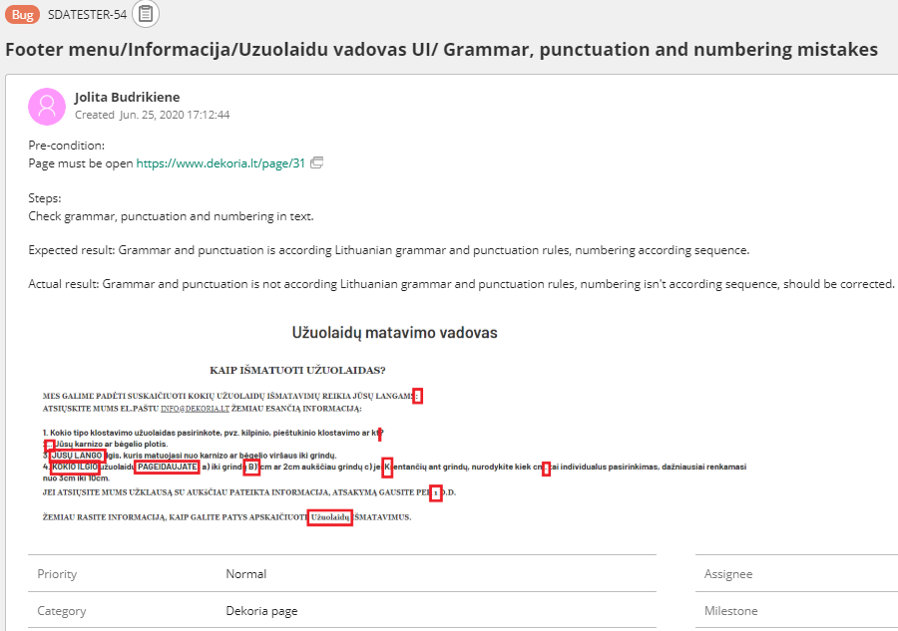
4. 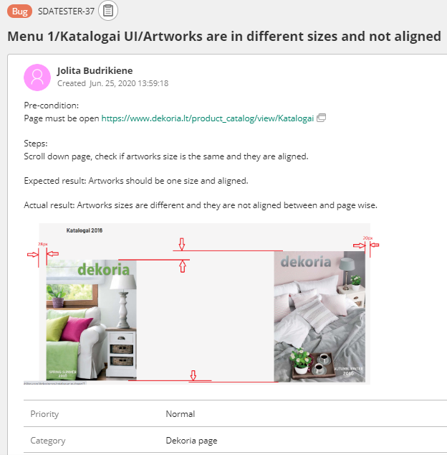

# **8. Improvements**

Suggested improvements:

* link to back page is not necessary, if it would be removed, page view would be clearer, cleaner;
* information, like press and enjoy is surplus, if it would be removed, page view would be clearer, cleaner;
* use blank space in top and end of pages, change placement of artworks to have more neat view;
* reduce long texts, where it is possible;
* correct style of text to look more professional;
* use one size, style, aligned artworks, titles in one style and language; it gives a better impression about company.

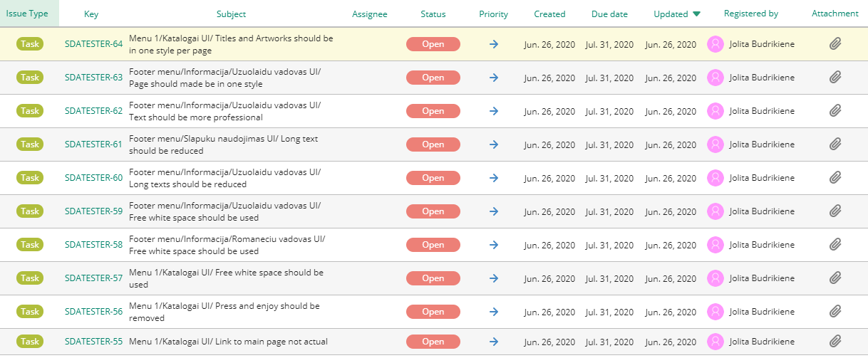

Improvement tasks examples:

1. 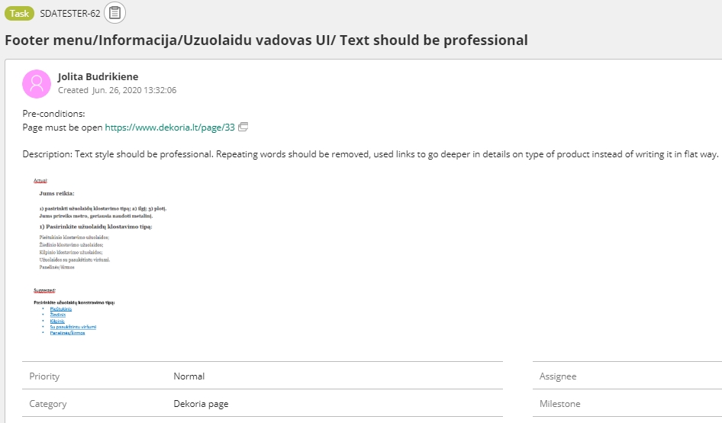
2. 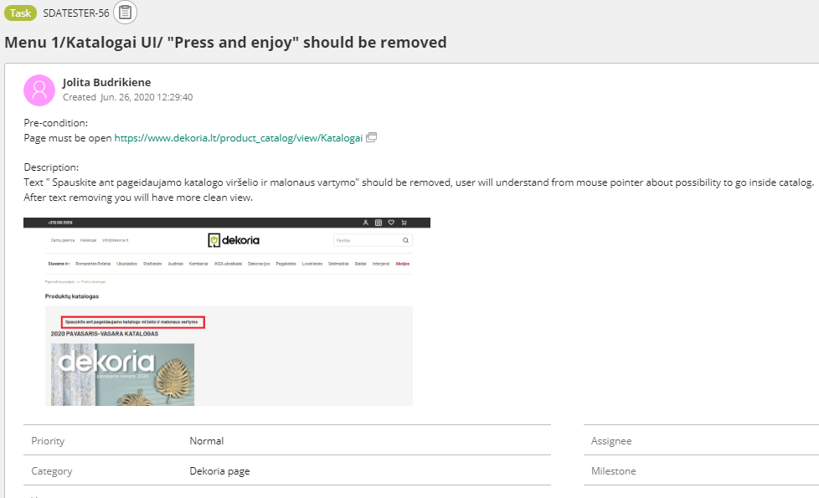
3. 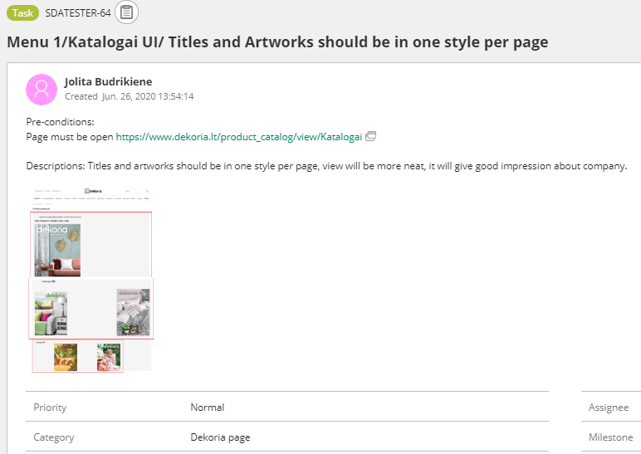
4. 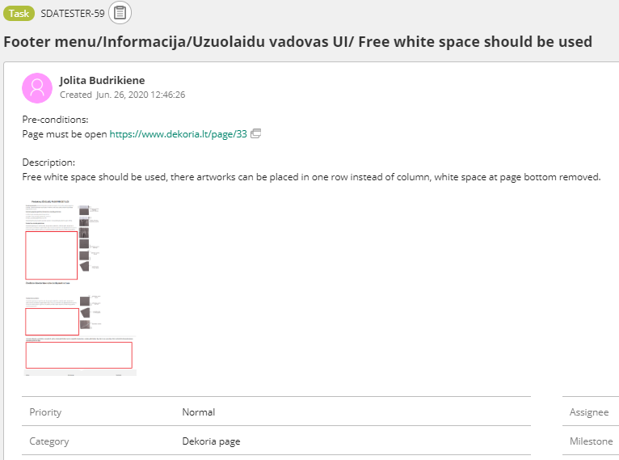

# **9. Test Design Technics**

While testing the page of <https://www.dekoria.lt/> test design techniques like Black-Box testing, Exploratory testing, Error guessing, Dynamic UI testing, Equivalence Partitioning were used.

# **10. Reflection**

While working on this project, I have noticed, that it would be handy to have more White-Box testing skills. That knowledge would be helpful to make even deeper testing and present more clear and understandable bugs description. It was not easy, in some cases, to understand if it is a mistake, or maybe, it is a design idea. Documents of product and possibility of discussion with designer and developer would make it clearer, it was not possible due to project concept.